Design and Simulation of TPS Worldwide's Enterprise Network Infrastructure
Using Cisco Packet Tracer

Department of Computer Science
Project Report

Submitted by:
SYEDA MAHAM IKRAM (23SP-101-CS)
FIZZA MUBBEN (23SP-070-CS)
MAHNOOR NADEEM (23SP-065-CS)
RABBANIA AKHTER (23SP-064-CS)
Semester: V
Section: B

Supervisor:
Sir Fauzan Saeed

Date:
May 2025

Abstract
This report presents the design and simulation of a scalable, secure, and enterprise-grade network infrastructure for TPS Worldwide, a leading fintech company headquartered in Karachi, Pakistan. The primary objective of this simulation is to replicate a real-world corporate environment that facilitates seamless communication, efficient resource sharing, and robust service delivery across multiple departments. The simulation is conducted using Cisco Packet Tracer, a widely adopted tool for network design, configuration, and validation.
The network infrastructure is built on a hierarchical model consisting of a core Layer 3 switch and multiple Layer 2 access switches. Each department within the organization is assigned a unique VLAN to ensure logical segmentation of traffic, reduce broadcast domains, and improve overall performance and security. The design includes VLANs for Development, QA, HR, Admin, Management, Server Infrastructure, and a Guest Wi-Fi network.
Essential services such as DHCP, DNS, FTP, and HTTP are hosted on a centralized server VLAN, providing dynamic IP allocation, domain resolution, file transfers, and internal web hosting. Each service is configured with static IP addresses, while client devices receive their network settings dynamically through DHCP. Domain names are resolved internally using a configured DNS server with appropriate A-record mappings.
Inter-VLAN routing is enabled on the core switch to allow controlled communication between departments. The configuration ensures that each department can securely access shared services without compromising the integrity of the network. Additionally, the network is connected to a simulated internet router, demonstrating external connectivity capabilities.
The project concludes with extensive testing of the network, including intra- and inter-VLAN communication, DHCP leases, DNS resolution, FTP authentication, and web server accessibility. These tests confirm that the network functions as expected and meets enterprise-level standards in terms of reliability, scalability, and performance.

Contents
1. Introduction 5
2. Project Objectives 6
• To design a logically segmented, scalable multi-department network architecture 6
• To deploy a two-tier network topology utilizing Layer 2 and Layer 3 switching 6
• To configure and validate critical enterprise network services 6
• To simulate a practical, real-world network environment using Cisco Packet Tracer 6
• To validate network functionality, service availability, and segmentation integrity 6
3. Company Overview 7
3.1 Organizational Layout at Karachi Headquarters 7
3.2 Floor-Based Department Allocation (Improvised for Simulation) 7
3.3 Simulated Network Scope 8
4. Network Design 8
4.1 Network Topology Overview 8
• Core Layer: 8
• Access Layer: 9
• Internet Access 9
4.2 VLAN and Subnet Design 10
4.3 Device Distribution 10
4.4 IP Addressing Scheme 10
4.5 Network Diagram 11
5. Server Infrastructure 12
5.1 List of Servers and Their Roles 12
5.2 Internal DNS Configuration 13
5.3 Server Connectivity and Integration 13
6. Configuration: 13
6.1 VLAN Creation (Access Switches) 14
6.2 Trunk Port Configuration (To Core Switch) 20
6.3 Core Switch Inter-VLAN Routing (Layer 3) 23
6.4 DHCP Server Configuration 25
6.5 DNS Server Setup 26
6.6 FTP & Web Server Setup 28
6.7 Device IP Assignment 32
6.8 Core Router Configuration 34
6.9 Internet Router Configuration 37
6.10 End Device (Laptop) Configuration 38
7. Testing and Verification 44
7.1 Intra-VLAN Connectivity (Same Department) 44
7.2 Inter-VLAN Routing 45
7.3 DHCP Functionality 46
7.4 DNS Resolution 47
7.5 FTP Server Access 47
7.6 Web Server Testing 48
8. Challenges and Solutions 48
8.1 VLAN Trunking Misconfiguration 48
8.2 DHCP Not Assigning IPs 49
8.3 DNS Not Resolving Hostnames 49
8.4 Inconsistent Inter-VLAN Routing 49
9. Conclusion 50
10. Appendix 50
10.1 DNS Server Configuration 50
10.2 FTP Access Verification 51
10.3 HTTP/Intranet Test 52
10.4 IP Addressing Table (DHCP Clients) 54

1. Introduction
TPS Worldwide is a prominent financial technology (fintech) company headquartered in Karachi, Pakistan. The company plays a vital role in the regional financial ecosystem by offering a wide array of digital services, including online payment platforms, secure transaction gateways, and integrated banking middleware solutions. With a growing client base and expanding digital infrastructure needs, TPS requires a network environment that is not only robust and efficient but also secure, scalable, and capable of adapting to future technological developments.
To meet these demands, a comprehensive enterprise-level network infrastructure is essential—one that can handle the day-to-day data flow across multiple departments, provide centralized access to business-critical services, and ensure seamless internal communication across various operational units. Departments such as Development, Quality Assurance, Human Resources, Administration, and Management all require consistent and secure access to shared resources like databases, file repositories, internal applications, and internet services.
This project simulates the internal network of TPS Worldwide's Karachi headquarters using Cisco Packet Tracer, a powerful network simulation platform that allows the design, testing, and troubleshooting of network topologies in a controlled virtual environment. The network architecture implemented follows a layered model, separating the core switching and routing functions from access-level device connectivity. Key elements include VLAN segmentation, Layer 2 and Layer 3 switching, and integration with multiple server-based services such as DHCP for dynamic IP allocation, DNS for internal name resolution, FTP for file sharing, and HTTP/HTTPS for intranet access.
By using VLANs, each department is logically isolated, which enhances both performance and security. The use of a Layer 3 switch as the network’s core enables inter-VLAN routing, allowing communication between departments while maintaining structured traffic flows. Additionally, a separate server VLAN hosts all enterprise services, keeping critical infrastructure logically and physically separated from user endpoints.
The purpose of this report is to document the network design process, detailing the planning, configuration steps, device roles, IP addressing scheme, and testing methodology used throughout the simulation. It also highlights the challenges encountered during implementation and the corresponding solutions. The outcome is a network infrastructure that reflects enterprise networking best practices, offering a solid foundation for TPS Worldwide’s operational needs and future expansion.

2. Project Objectives
The goal of this project is to design, configure, and simulate a realistic enterprise-level network for TPS Worldwide, reflecting the infrastructure requirements of a modern fintech organization. The project focuses on achieving both functional and structural objectives, using Cisco Packet Tracer as the simulation platform. The key objectives are as follows:
- To design a logically segmented, scalable multi-department network architecture
Implement VLANs (Virtual Local Area Networks) to logically separate traffic between departments such as Development, Quality Assurance, HR, Admin, and Management. This segmentation improves security, minimizes broadcast domains, and enhances network performance.
- To deploy a two-tier network topology utilizing Layer 2 and Layer 3 switching
Implement Layer 2 access switches for end-device connectivity and a Layer 3 core switch to perform inter-VLAN routing and central traffic management. This layered approach ensures optimized traffic flow, centralized control, and better scalability.
- To configure and validate critical enterprise network services
Integrate essential services such as:
  - DHCP (Dynamic Host Configuration Protocol): for automatic IP address allocation across departments
  - DNS (Domain Name System): for internal hostname resolution and easier access to services
  - FTP (File Transfer Protocol): to enable secure file exchange, primarily for Development and QA teams
  - HTTP/HTTPS (Web Services): to host an internal intranet accessible across all departments
- To simulate a practical, real-world network environment using Cisco Packet Tracer
Create a topology that closely mirrors the physical layout of TPS Worldwide’s Karachi HQ. This includes a core switch, departmental access switches, servers, routers, and client endpoints. The simulation demonstrates the use of Cisco IOS CLI for hands-on configuration and management.
- To validate network functionality, service availability, and segmentation integrity
Perform extensive testing to ensure that devices receive correct IP configurations, can communicate across VLANs as required, and access network services without conflict. The testing phase will also verify that services like DHCP, DNS, FTP, and web servers function as expected from various VLANs.

3. Company Overview
TPS Worldwide is a renowned financial technology company headquartered in Karachi, Pakistan. Since its inception, TPS has specialized in digital payment systems, secure transaction processing, payment gateway solutions, banking middleware, and integration of financial APIs. The company serves a wide array of clients including banks, telcos, fintech startups, and government entities across South Asia, the Middle East, and Africa.
TPS is recognized for its role in powering core payment infrastructures such as real-time ATM switching, POS management, mobile wallet platforms, and EMV card issuance systems. These mission-critical services demand an underlying IT and network infrastructure that is both highly available and secure.

3.1 Organizational Layout at Karachi Headquarters
The TPS Karachi HQ acts as the central hub for software development, quality assurance, systems engineering, and corporate administration. While TPS occupies multiple floors in its Karachi premises, the exact structural layout is not publicly detailed. Therefore, for the purpose of this project, we have made reasonable design improvisations to mirror how enterprise networks are typically distributed across floors and departments in a mid-sized corporate facility.

3.2 Floor-Based Department Allocation (Improvised for Simulation)
- Ground Floor
  - Guest Wi-Fi Network (VLAN 70)
  - Reception & Admin + Finance (VLAN 40)
- 1st Floor
  - Human Resources (VLAN 30)
  - Management Offices (VLAN 60)
- 2nd Floor
  - Development Department (VLAN 10)
  - Quality Assurance (QA) Lab (VLAN 20)
- 3rd Floor (Data Center)
  - Server Room with DNS, DHCP, FTP and Web(VLAN 50)
  - IT Infrastructure & Core Networking Devices

3.3 Simulated Network Scope
This project simulates the network infrastructure of TPS’s Karachi HQ by building a layered enterprise network topology using Cisco Packet Tracer. The simulation covers the following aspects:
- Logical segmentation of departments using VLANs
- Deployment of Layer 2 and Layer 3 switching
- Centralized services hosted in a dedicated Server VLAN
- DHCP for automated IP assignment
- DNS for internal name resolution
- FTP & HTTP services for file transfer and intranet access
- A simulated connection to the Internet via a router
The project aims to reflect realistic enterprise network principles while remaining within the constraints of simulation tools and publicly available company structure.

4. Network Design
The network design for TPS Worldwide is structured around a hierarchical model commonly adopted in enterprise environments. This design enables efficient data flow, centralized control, and logical segmentation using VLANs. The architecture consists of a Layer 3 core switch and multiple Layer 2 access switches, along with a dedicated server infrastructure and simulated internet access via a cloud router.
This design not only ensures scalability and maintainability but also isolates departmental traffic to improve both security and performance.

4.1 Network Topology Overview
The simulated infrastructure follows the Core-Access model:

Core Layer:
  - Layer 3 Multilayer Switch (Cisco Catalyst 3560)
    - Handles inter-VLAN routing using Switched Virtual Interfaces (SVIs)
    - Acts as the central distribution point for internal communication
    - Directly connected to:
      - 6 departmental access switches (Access Layer)
      - All servers (VLAN 50) — servers are connected directly to this multilayer switch
      - Core Router (Cisco 2911)
  - Core Router (Cisco 2911)
    - Provides WAN connectivity
    - Connects to:
      - The Layer 3 Multilayer Switch (for internal routing)
      - The Internet Router (Cisco 2911) (for external Internet access)

Access Layer:
  - 1 × Layer 2 Access Switch per department
  - Connects PCs, printers, laptop, and other user-end devices
Server Infrastructure:
Servers are physically located on a dedicated server floor (3rd floor in the simulation)
Host all core enterprise services:
  - DHCP, DNS, FTP, HTTP, and Syslog
- Directly connected to the Layer 3 Multilayer Switch (Cisco Catalyst 3560)
  - Assigned to VLAN 50
  - No separate Layer 2 switch is used for server connectivity

Internet Access
Internet access is simulated using a dedicated Internet Router (Cisco 2911)
This Internet Router is connected to the Core Router (Cisco 2911)
  - The Core Router serves as the main internal gateway and connects to the Layer 3 Multilayer Switch
This routing structure ensures:
  - Controlled traffic flow between internal network and internet
  - Realistic simulation of WAN connectivity without using the cloud device

4.2 VLAN and Subnet Design

Department | VLAN ID | Subnet | Gateway IP
Development | 10 | 192.168.10.0/24 | 192.168.10.1
Quality Assurance | 20 | 192.168.20.0/24 | 192.168.20.1
Human Resources | 30 | 192.168.30.0/24 | 192.168.30.1
Admin & Finance | 40 | 192.168.40.0/24 | 192.168.40.1
Server VLAN | 50 | 192.168.50.0/24 | 192.168.50.1
Management | 60 | 192.168.60.0/24 | 192.168.60.1
Guest Wi-Fi | 70 | 192.168.70.0/24 | 192.168.70.1

Each VLAN is routed via an SVI (Switch Virtual Interface) configured on the Layer 3 core switch.

4.3 Device Distribution

VLAN | Devices
Development | 50 PCs, 5 Printers
QA | 30 PCs, 5 Printers
HR | 20 PCs, 5 Printers
Admin | 20 PCs, 5 Printers
Management | 10 PCs
Server VLAN | 10 Static-IP Servers
Guest | 10 Wireless Devices(ROUTER) + (LAPTOP)

This distribution reflects typical enterprise needs for both productivity and administrative functions.

4.4 IP Addressing Scheme

- Static IPs: Assigned to all servers (DNS, DHCP, FTP, Web), core switch interfaces, A dedicated Cisco 2911 router (Internet-Router) is used to simulate external internet access.
- DHCP: Used for dynamic IP allocation to all end-user devices in each VLAN
- IP subnets are consistently aligned with VLAN IDs for simplified troubleshooting and configuration

4.5 Network Diagram

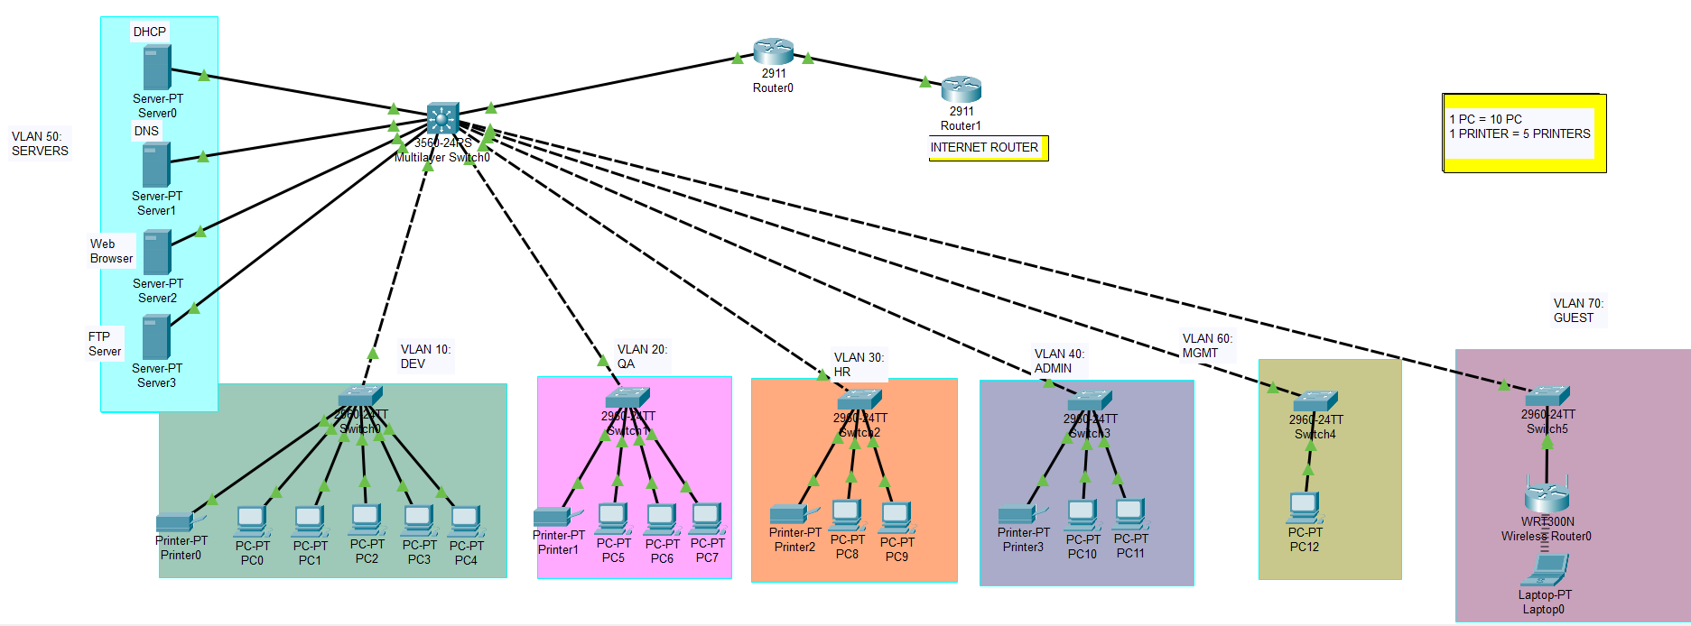

CORE LAYER:
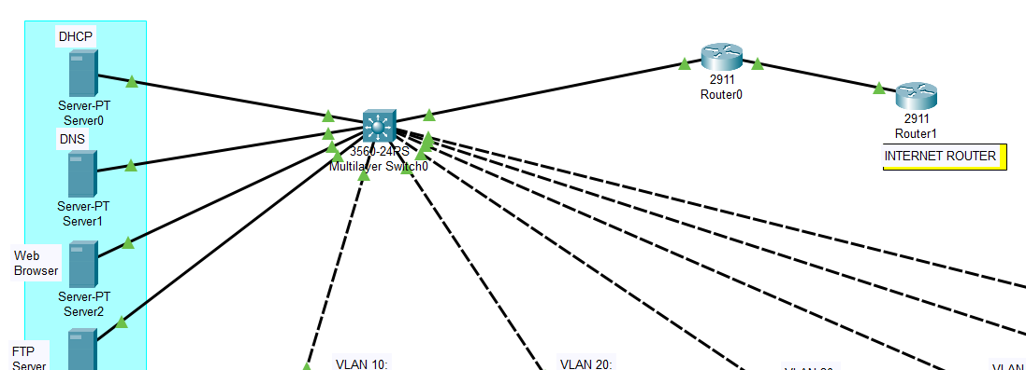

ACCESS LAYER:
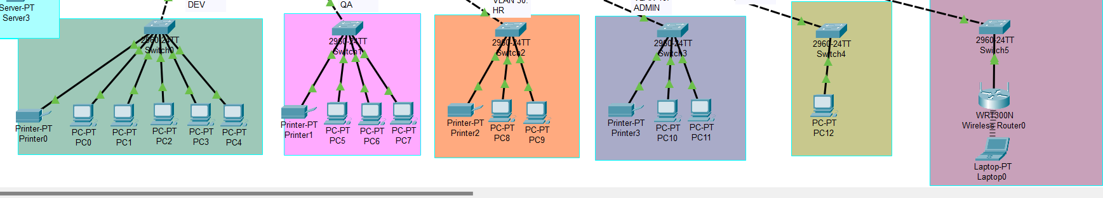

This diagram provides a visual representation of the overall network design, showing how devices, switches, servers, and routers are interconnected across the floors.

5. Server Infrastructure
A centralized server infrastructure is essential for ensuring the availability of core services such as IP address assignment, domain resolution, file sharing, and intranet hosting. These services are deployed in VLAN 50, also referred to as the Server VLAN, and are hosted on dedicated servers with static IP addresses to guarantee reliable communication across all departments.
This setup provides a centralized control plane for IT services, ensuring accessibility, fault isolation, and secure operations throughout the network.

5.1 List of Servers and Their Roles
The following servers are deployed within VLAN 50, each assigned a unique static IP address:
Server Name | Function | IP Address
DHCP Server | Assigns dynamic IP addresses to clients | 192.168.50.10
DNS Server | Resolves internal domain names | 192.168.50.20
FTP Server | Handles file transfers for Dev and QA | 192.168.50.30
Web Server | Hosts the internal intranet site (HTTP/HTTPS) | 192.168.50.40

Each server was configured manually using the built-in services provided by Cisco Packet Tracer’s server devices.

5.2 Internal DNS Configuration
The DNS server is preloaded with A-records (host-to-IP mappings) to support hostname resolution across VLANs. These domain names simplify access to internal services and improve user experience.
Hostname | Mapped IP Address
google.com | 8.8.8.8
www.tpsworldwide.com | 192.168.50.50
hr.tps.com | 192.168.30.109
ftp.tps.com | 192.168.50.70
intranet.tps.com | 192.168.50.60
End-user devices were able to successfully resolve these domain names using the nslookup command or web browser testing.

5.3 Server Connectivity and Integration
- All servers are physically connected to a dedicated Layer 2 switch within VLAN 50.
- This server switch is trunk-linked to the Core Layer 3 Switch, enabling full routing between departments and the server network.
- Each service was individually tested:
  - Ping was used to verify basic connectivity.
  - NSLookup validated domain resolution through the DNS server.
  - FTP clients from VLAN 10 and VLAN 20 were able to authenticate and transfer files.
  - The web server responded to HTTP/HTTPS requests from client PCs using intranet.tps.com and its IP address.
This centralized approach enhances reliability and ensures uniform access to enterprise resources across the TPS Worldwide network.

6. Configuration:
The network was implemented and tested in Cisco Packet Tracer, with all configurations manually applied to switches, routers, servers, and end devices.

6.1 VLAN Creation (Access Switches)
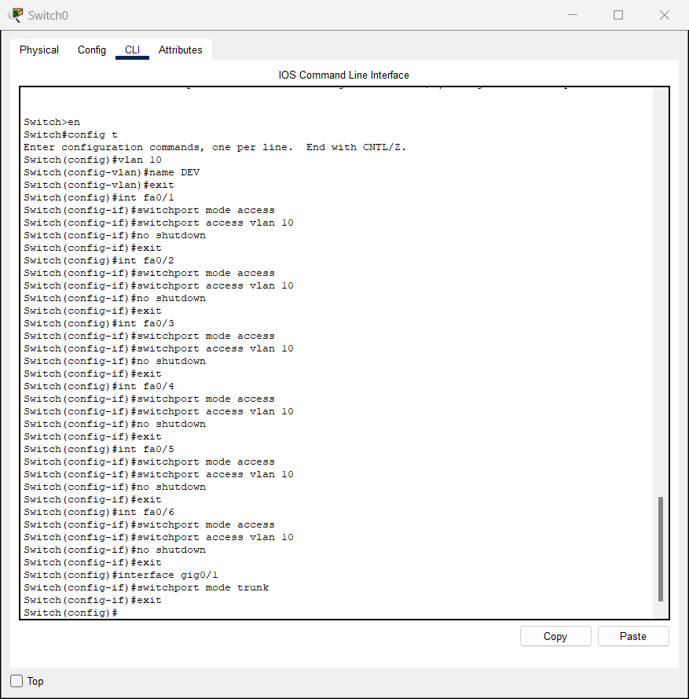

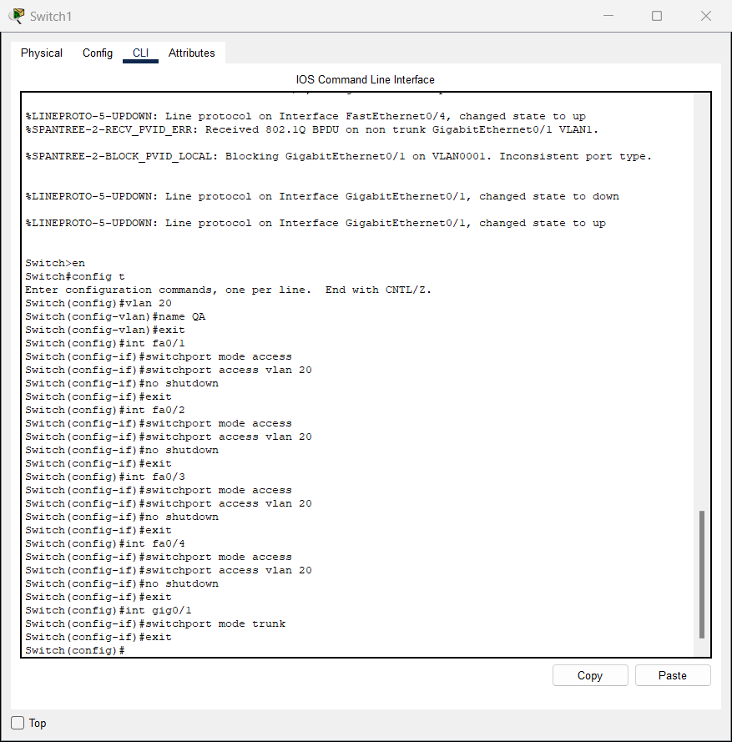
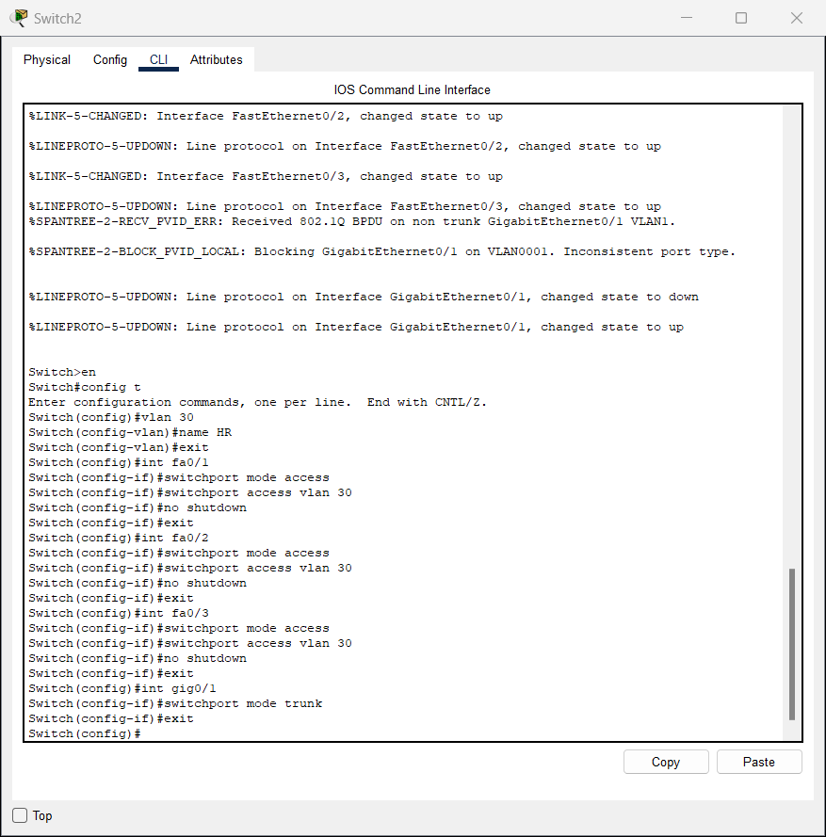
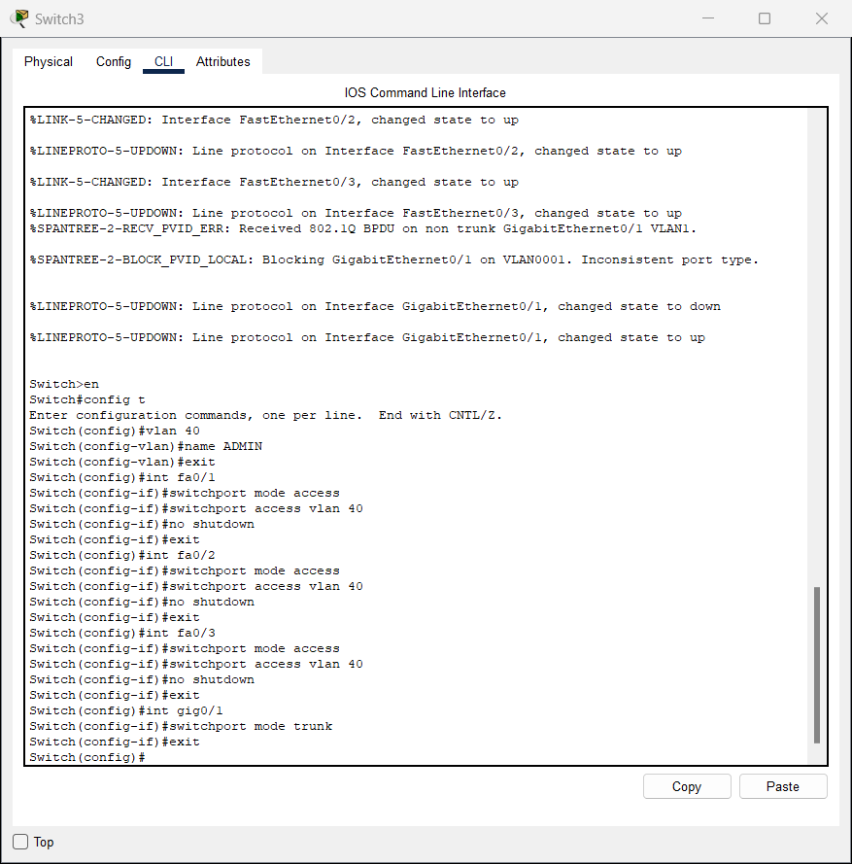
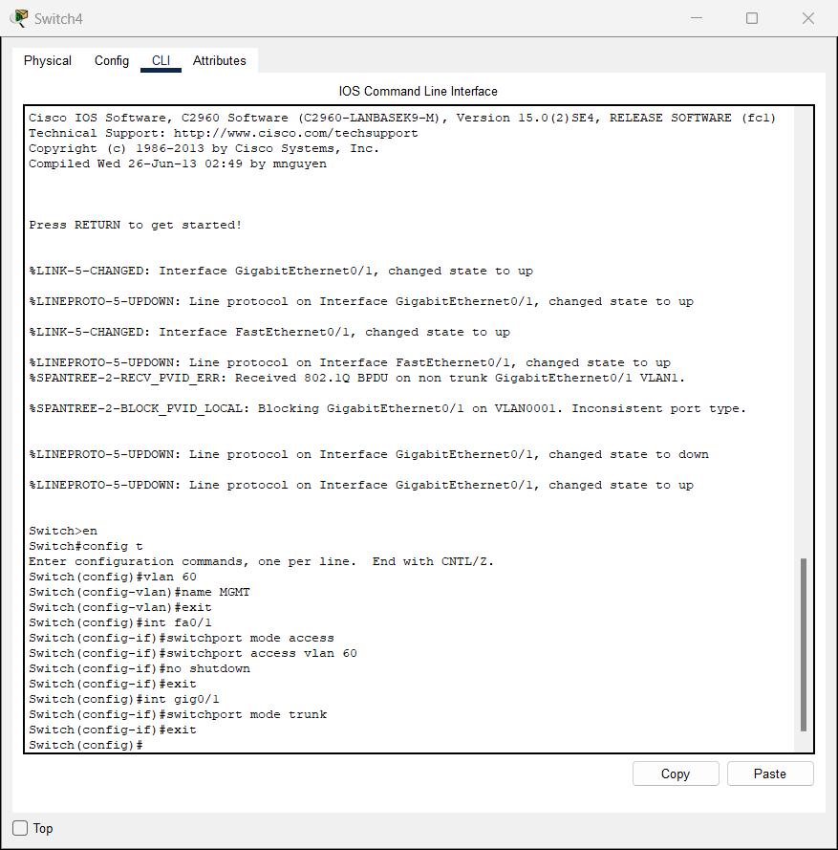
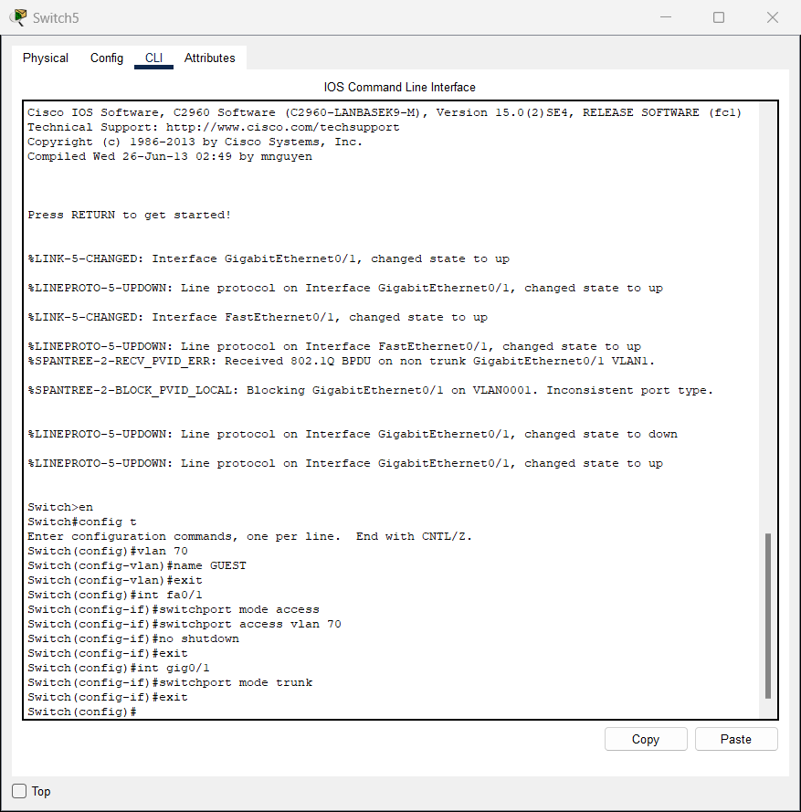

6.2 Trunk Port Configuration (To Core Switch)
All vlans:
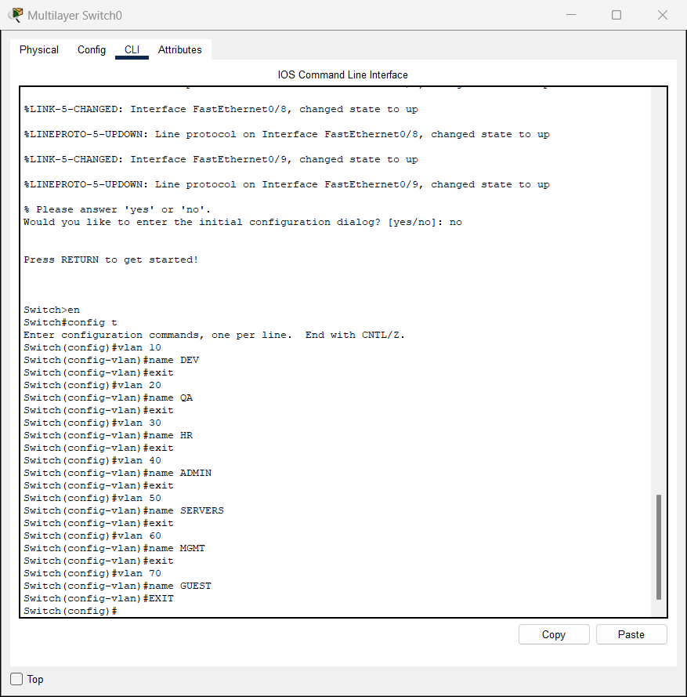
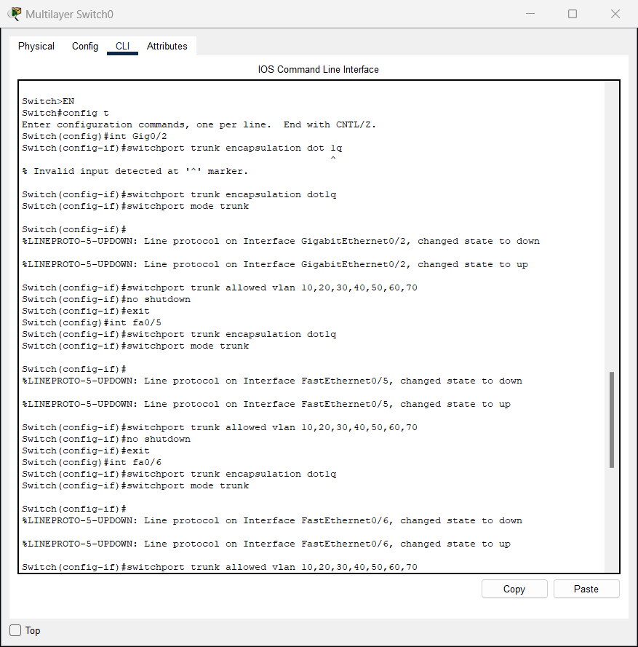
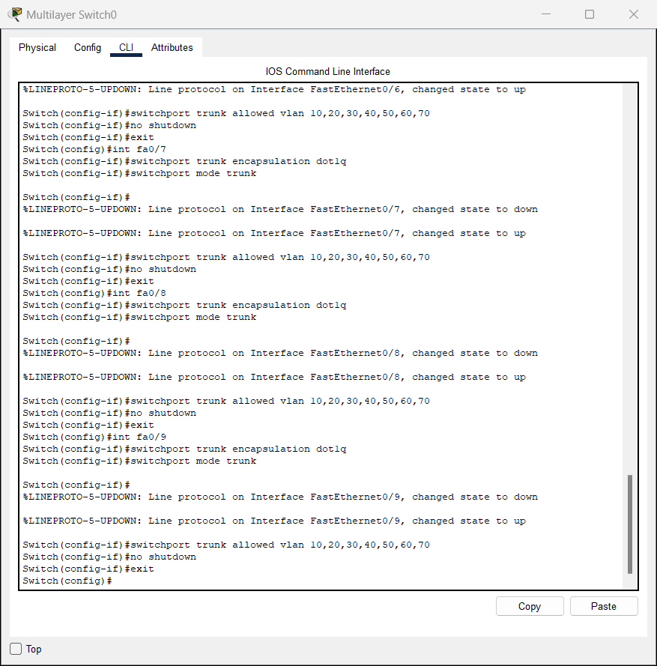

6.3 Core Switch Inter-VLAN Routing (Layer 3)
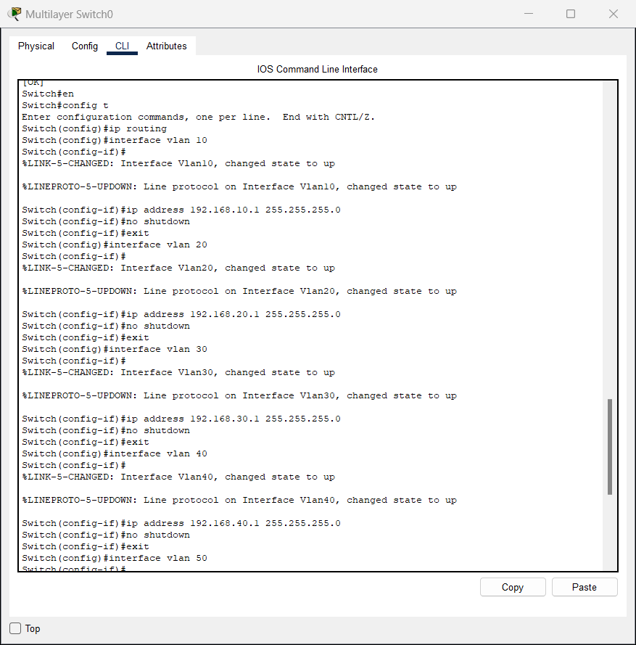
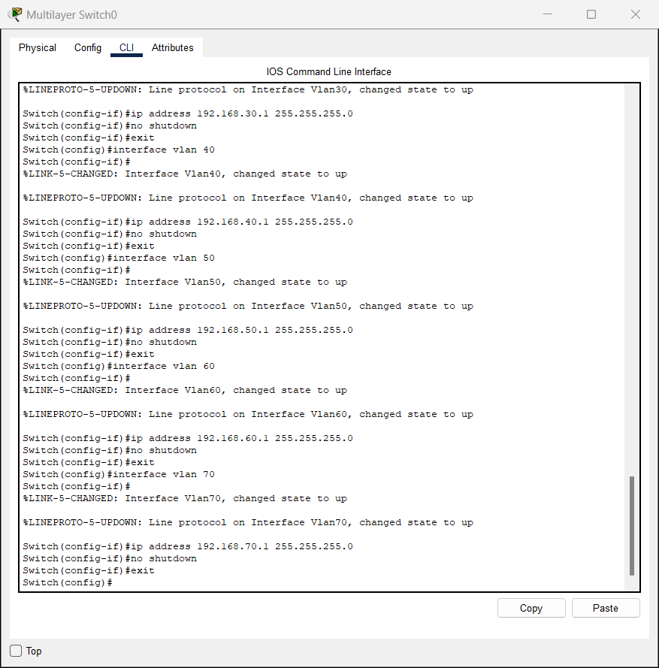

6.4 DHCP Server Configuration
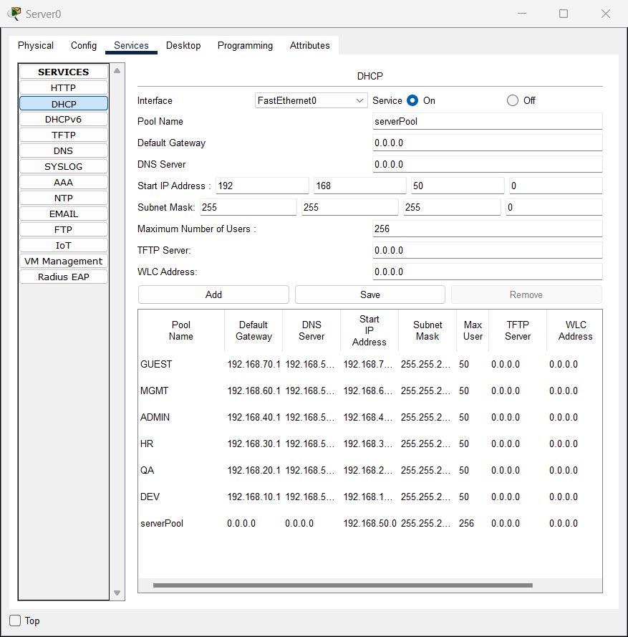

6.5 DNS Server Setup
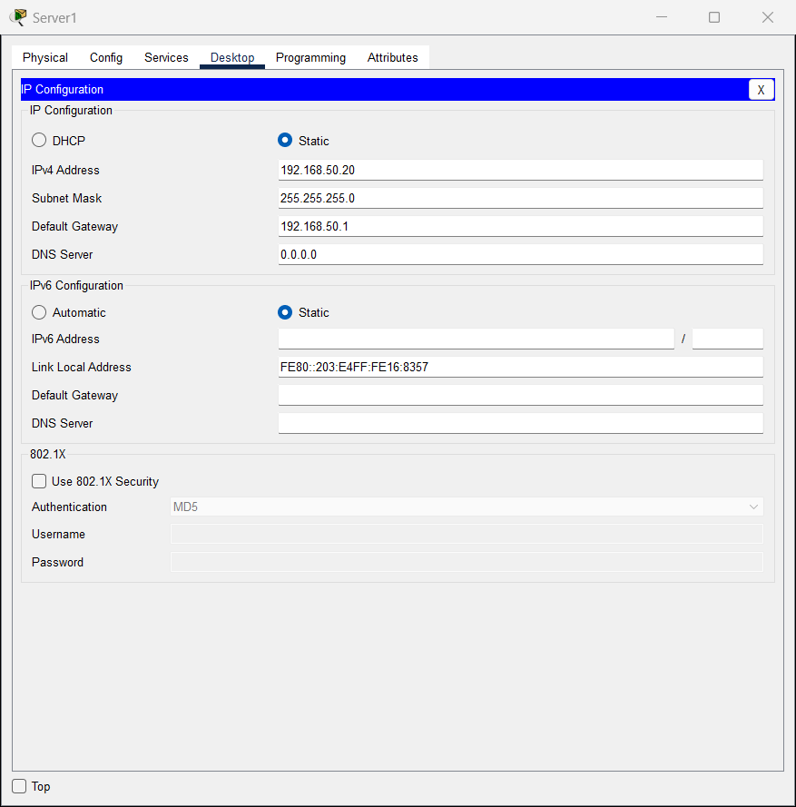
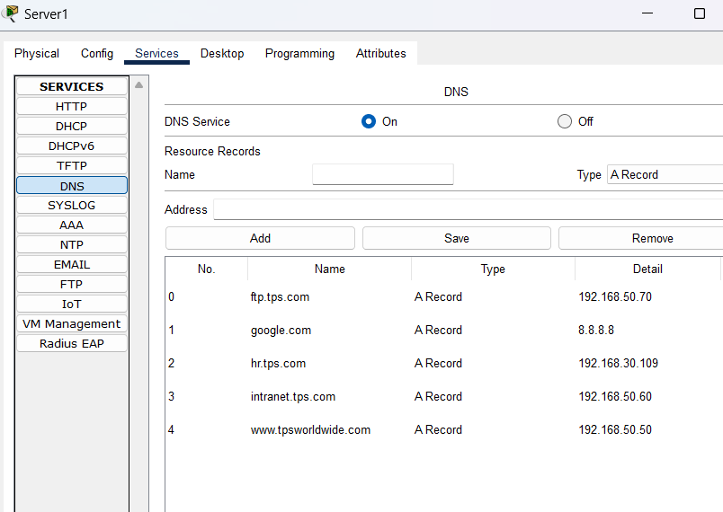

6.6 FTP & Web Server Setup
Assign static IPs:
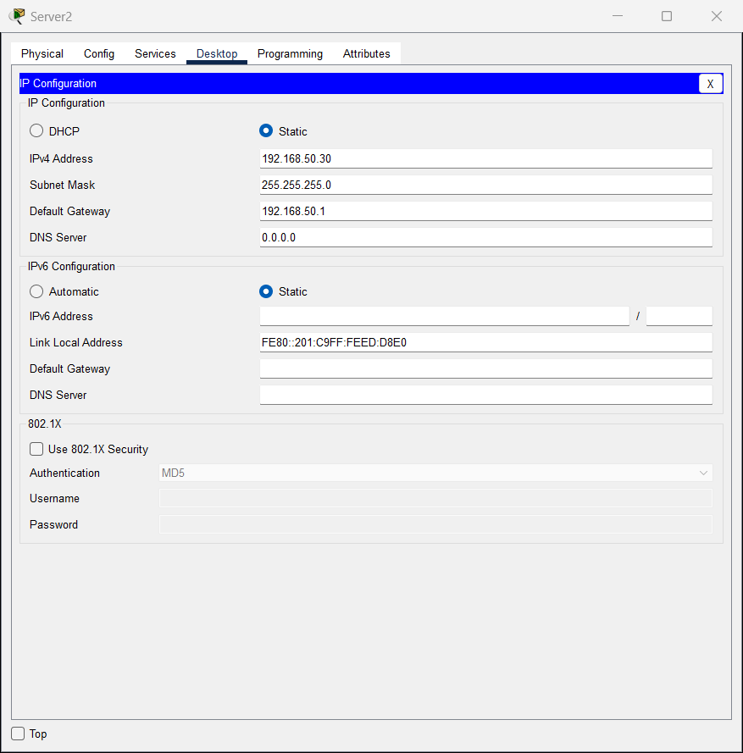
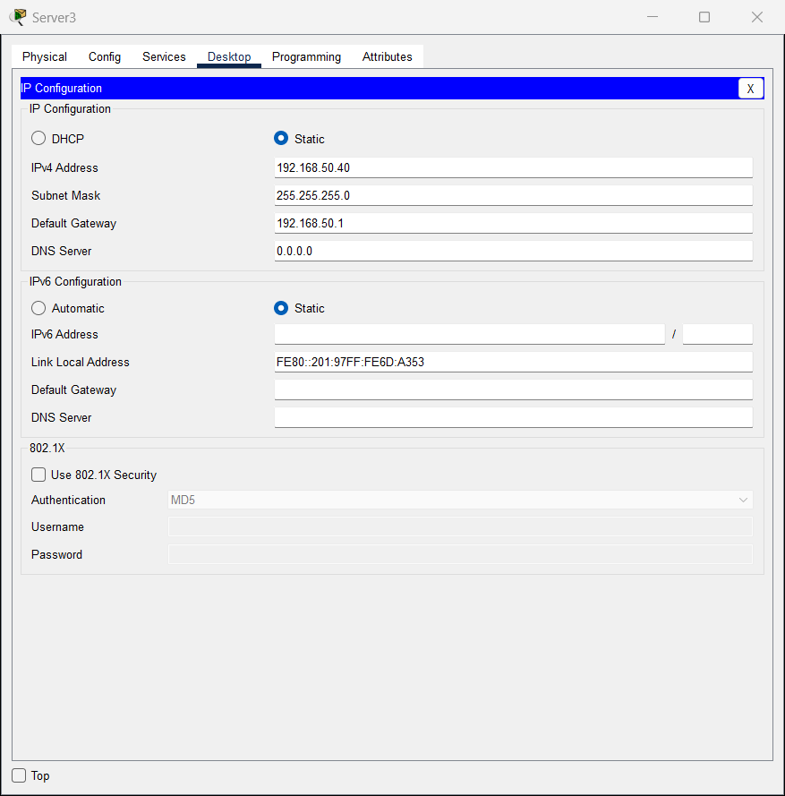

Create FTP users:
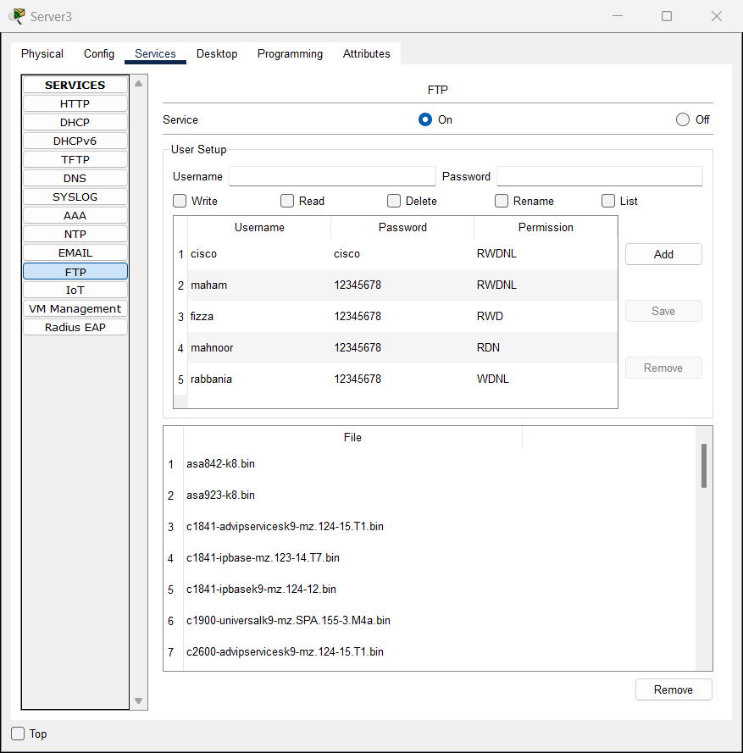

Web browser:
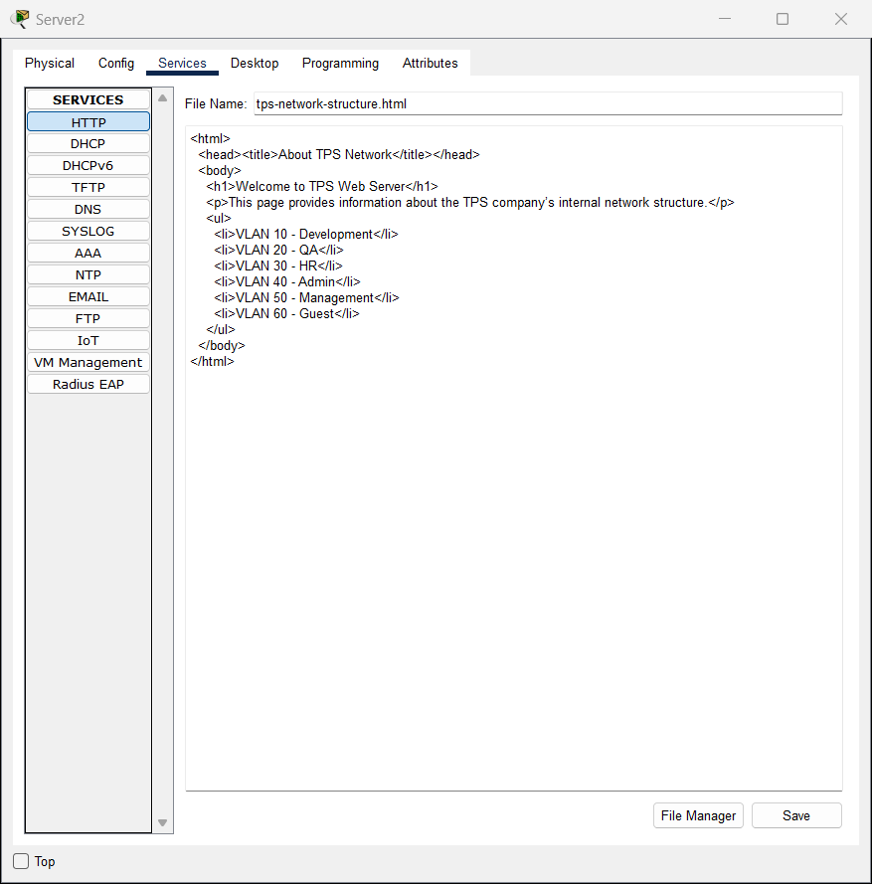

6.7 Device IP Assignment
- Servers:
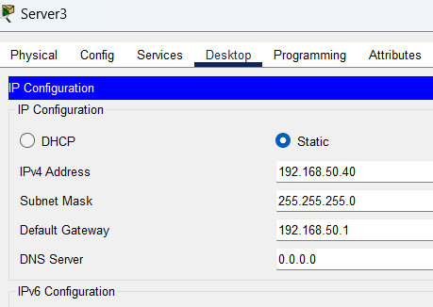
- End-user Devices: IPs via DHCP
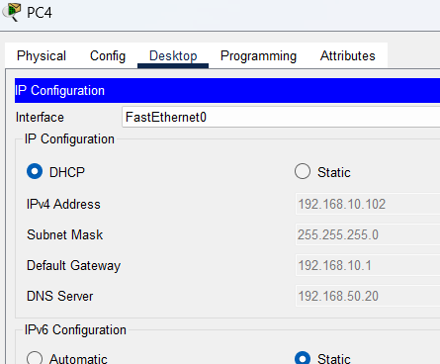

- Printers: Static IPs in departmental subnets
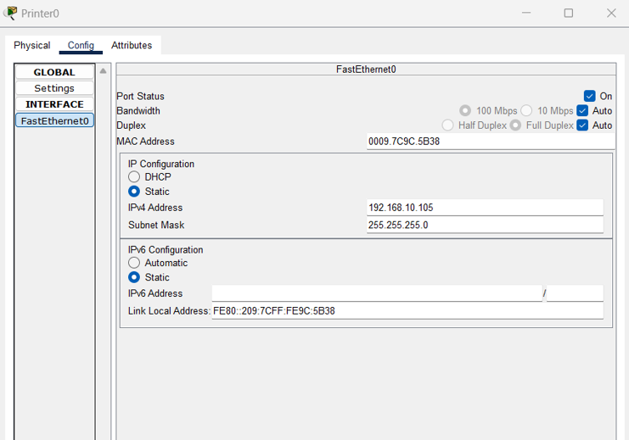

6.8 Core Router Configuration
Covers the configuration of the Core Router (Cisco 2911), including:
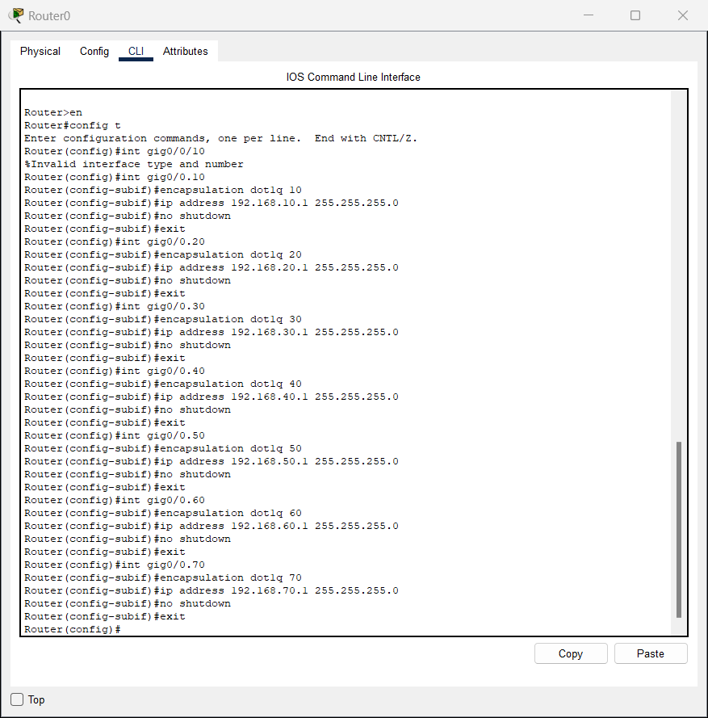
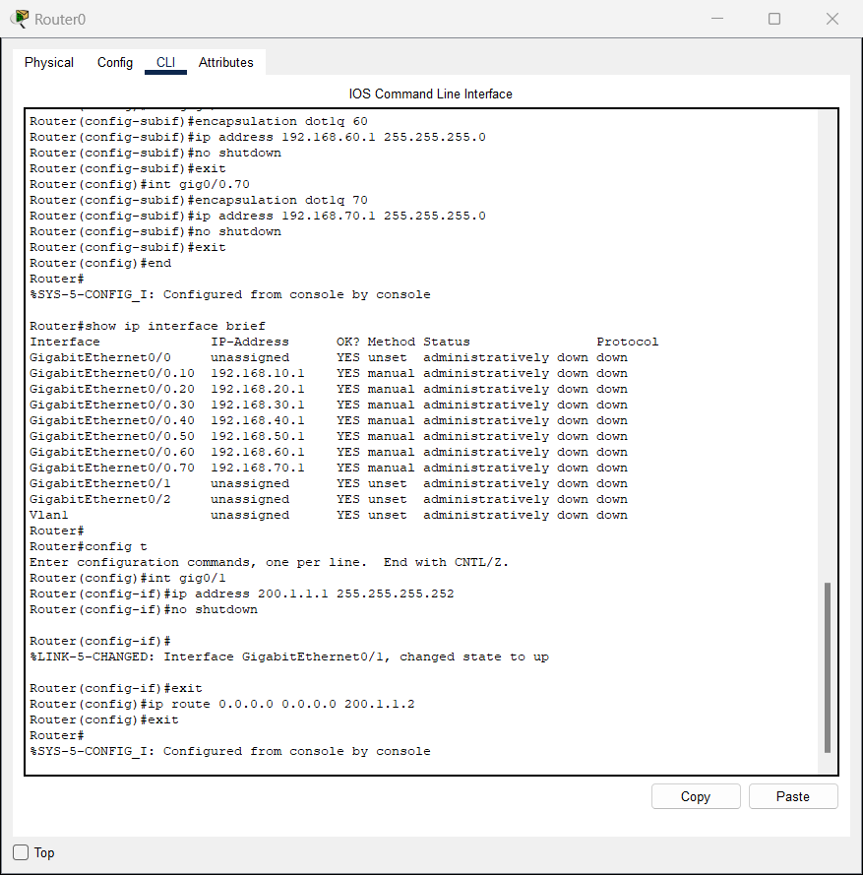
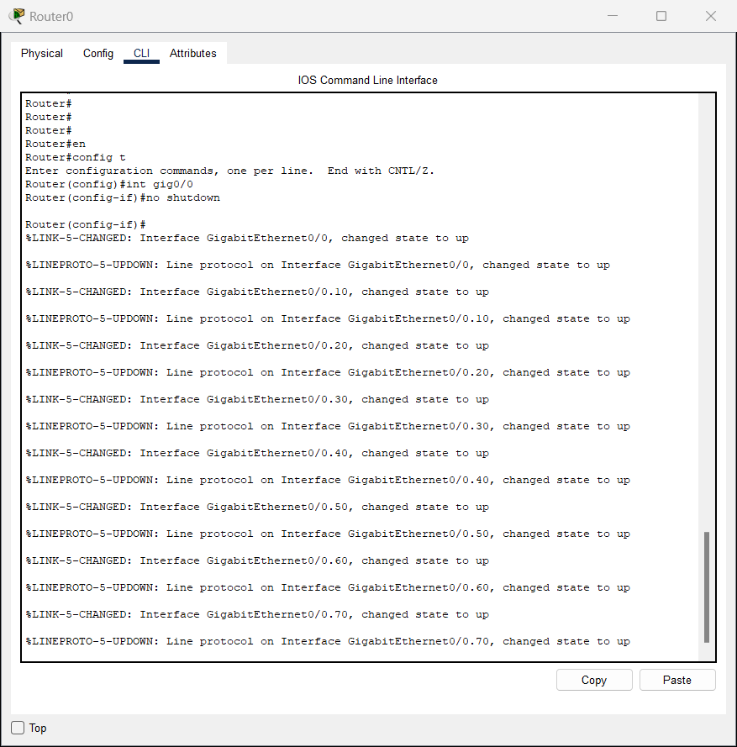

6.9 Internet Router Configuration
Outlines the configuration of the Internet Router (Cisco 2911)
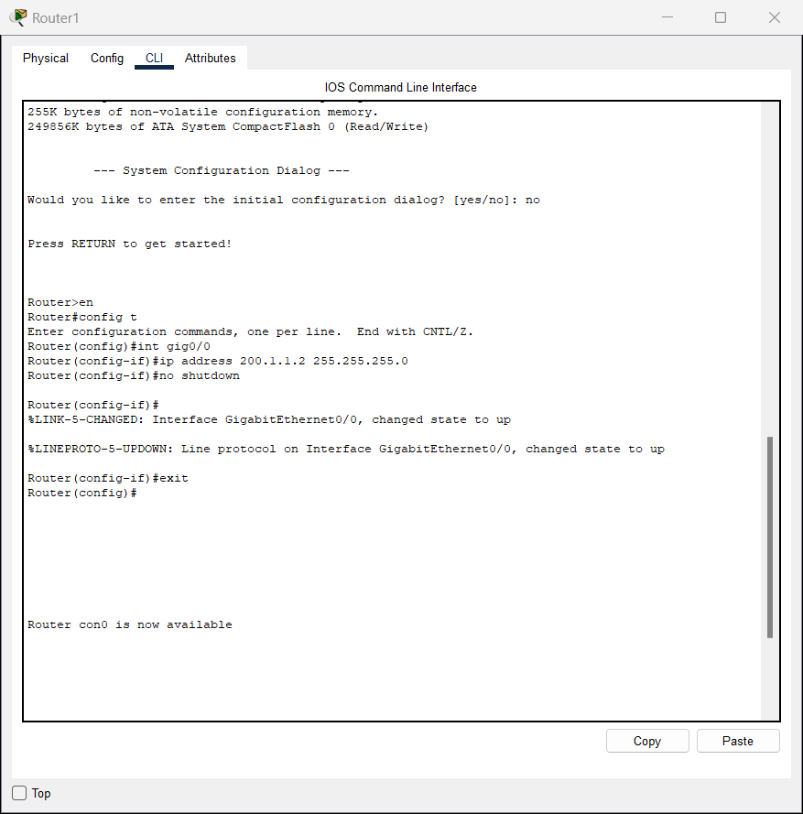

6.10 End Device (Laptop) Configuration
Provides configuration steps for end-user devices such as laptops
ADD WPC300N:
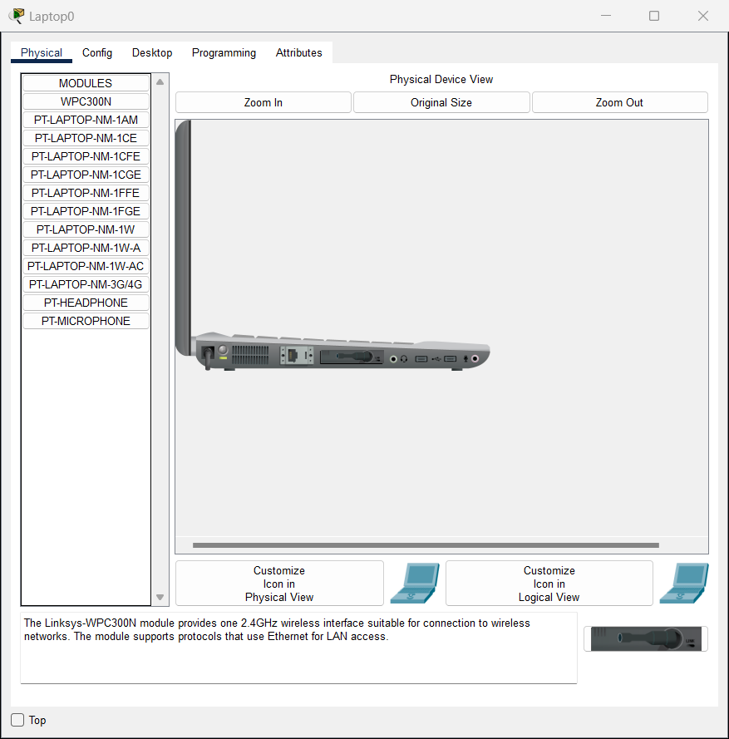
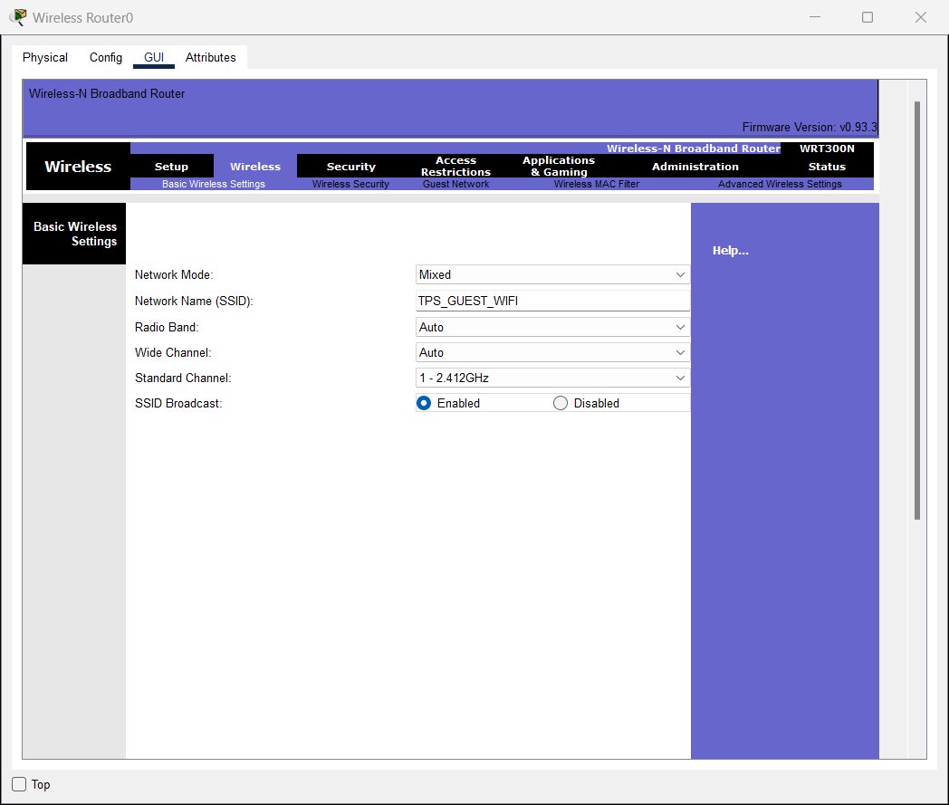
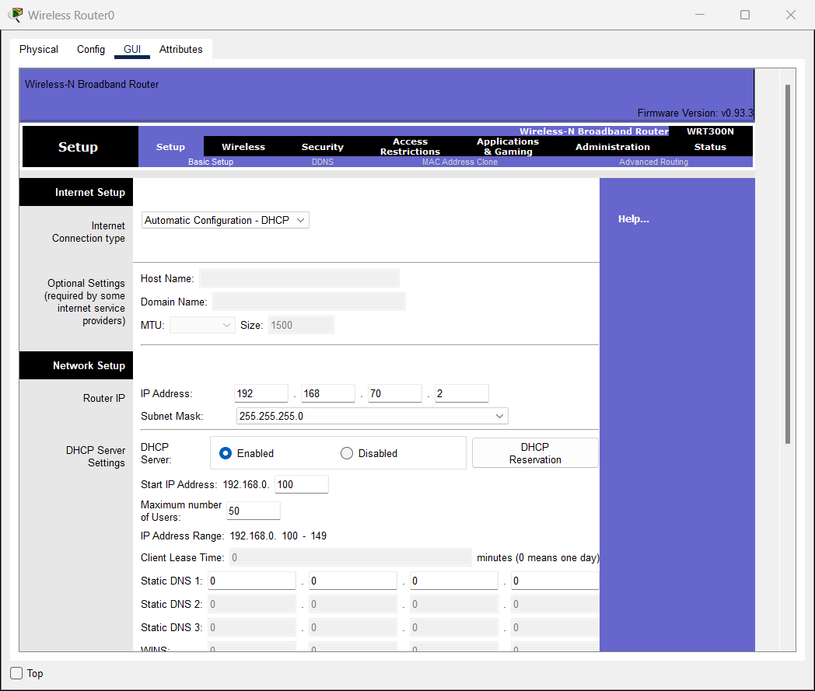

CONFIG ON ROUTERS FOR INTERNET CONNECTION:
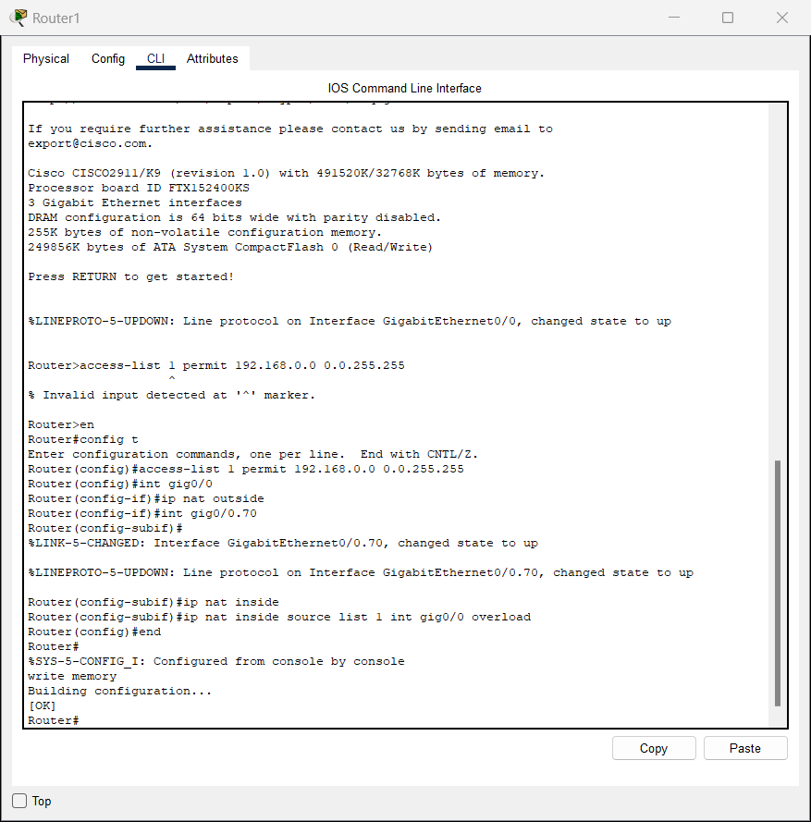
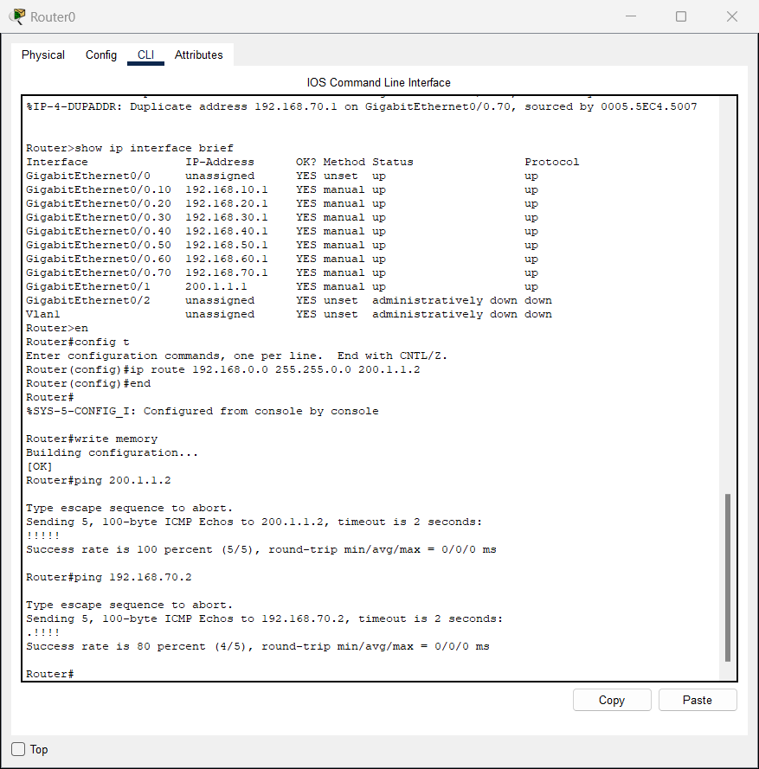

TO SHOW INTERNET IS WORKING:
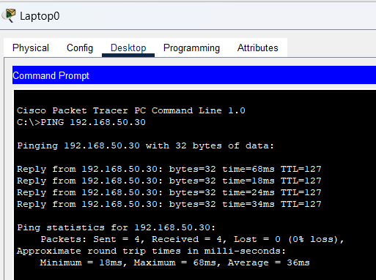

7. Testing and Verification
To ensure network functionality, a series of tests were conducted on connectivity, services, and inter-VLAN routing. Each component was verified using command-line utilities within Cisco Packet Tracer.

7.1 Intra-VLAN Connectivity (Same Department)
- PCs within the same VLAN/subnet were tested using the ping command.
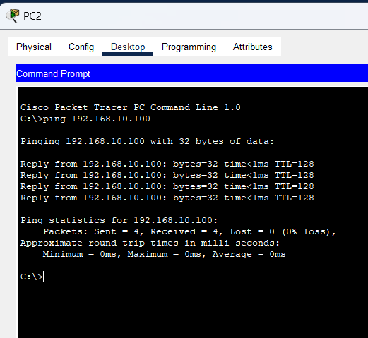

7.2 Inter-VLAN Routing
- Devices in different VLANs communicated via the Layer 3 Core Switch.

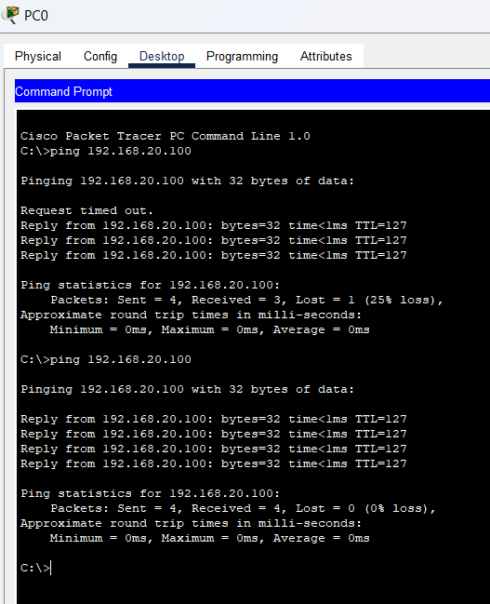

7.3 DHCP Functionality
- End devices in each VLAN were assigned IP addresses dynamically.
- Verified using ipconfig on PCs

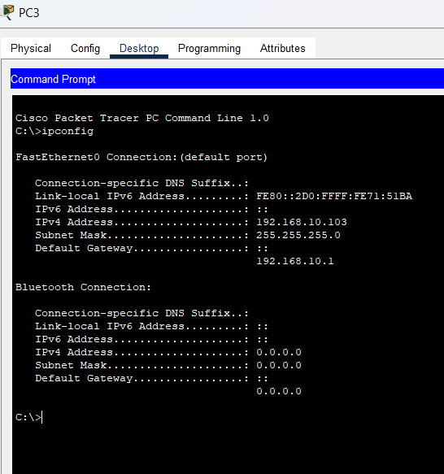

7.4 DNS Resolution
- Hostnames were resolved correctly using nslookup.
- Internal DNS resolution verified.
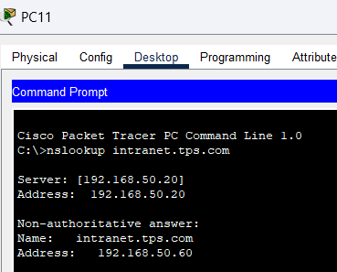

7.5 FTP Server Access
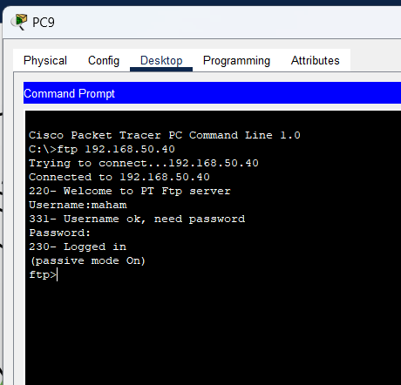
- FTP access tested from VLANs 10 (Dev) and 20 (QA).
- Users connected using:
- ftp 192.168.50.40
- Username: maham
- Password: 12345678
✅ Result: Successful login

7.6 Web Server Testing
- HTTP server tested by entering 192.168.50.30 in a web browser.
- Displayed a custom index.html page.
✅ Result: Intranet web services operational.

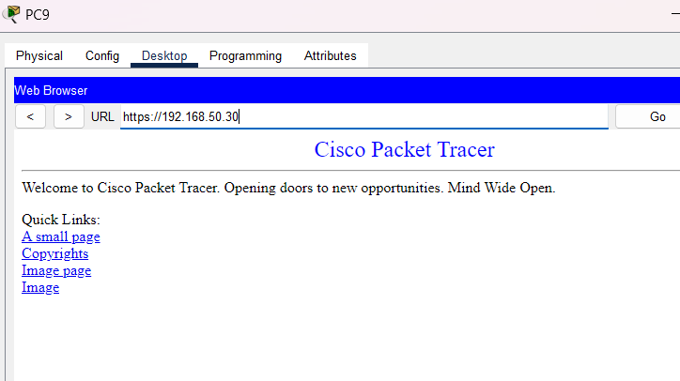

8. Challenges and Solutions
During the configuration and testing of TPS Worldwide’s network simulation, several technical challenges were encountered. These were addressed systematically to ensure a stable and fully functional deployment.

8.1 VLAN Trunking Misconfiguration
Issue:
Devices in different VLANs couldn’t communicate initially due to improper trunk configuration between the core and access switches.
Solution:
Enabled dot1q trunk encapsulation and ensured trunk ports were correctly assigned on both ends:
Switch(config)# interface fa0/1
Switch(config-if)# switchport mode trunk
Switch(config-if)# switchport trunk encapsulation dot1q

8.2 DHCP Not Assigning IPs
Issue:
DHCP clients were not receiving IP addresses on some VLANs.
Solution:
Verified that:
- VLAN interfaces on the core switch were up (no shutdown)
- DHCP pools had correct subnet, default router, and DNS
- DHCP server was reachable across VLANs

8.3 DNS Not Resolving Hostnames
Issue:
DNS queries failed for internal domains.
Solution:
Configured A-records on the DNS server with correct hostnames and IPs (e.g., dev.tps.com → 192.168.10.100) and tested resolution using nslookup.

8.4 Inconsistent Inter-VLAN Routing
Issue:
Some devices could ping across VLANs while others could not.
Solution:
Ensured:
- IP routing was enabled on the Layer 3 switch (ip routing)
- VLAN interfaces had correct IPs
- Devices had correct gateways via DHCP or manual config

9. Conclusion
This project successfully demonstrated the design and simulation of a realistic enterprise network infrastructure for TPS Worldwide using Cisco Packet Tracer. By implementing a layered architecture with VLAN segmentation, inter-VLAN routing, and centralized server services, the network model mirrors the standards used in corporate environments.
Key services such as DHCP, DNS, FTP, and web hosting were configured and validated. The network supports over 180 devices across multiple departments while ensuring reliable communication and service delivery.
The simulation highlights best practices in network design, including logical separation through VLANs, static IP allocation for core devices, and the use of a Layer 3 switch for efficient inter-VLAN routing. The result is a scalable, secure, and operationally sound network capable of supporting TPS Worldwide’s technological needs.

10. Appendix
This section contains relevant configuration screenshots and command references used throughout the implementation of the network. These were taken directly from Cisco Packet Tracer simulations.

10.1 DNS Server Configuration
📷 DNS A-record mappings like dev.tps.com → 192.168.10.100
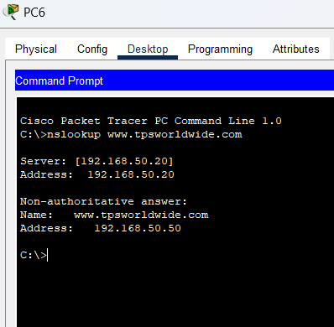

10.2 FTP Access Verification
📷 Client PC terminal showing FTP login success with user credentials


10.3 HTTP/Intranet Test
📷 Browser window displaying index.html page from web server
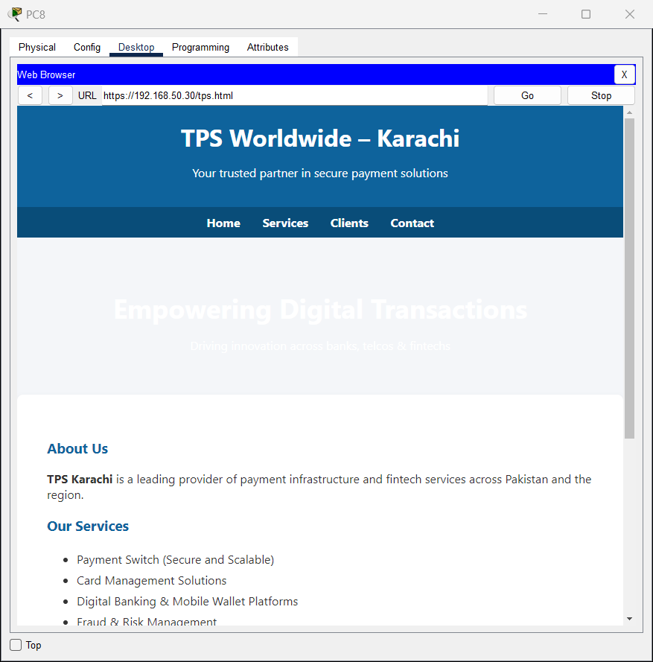

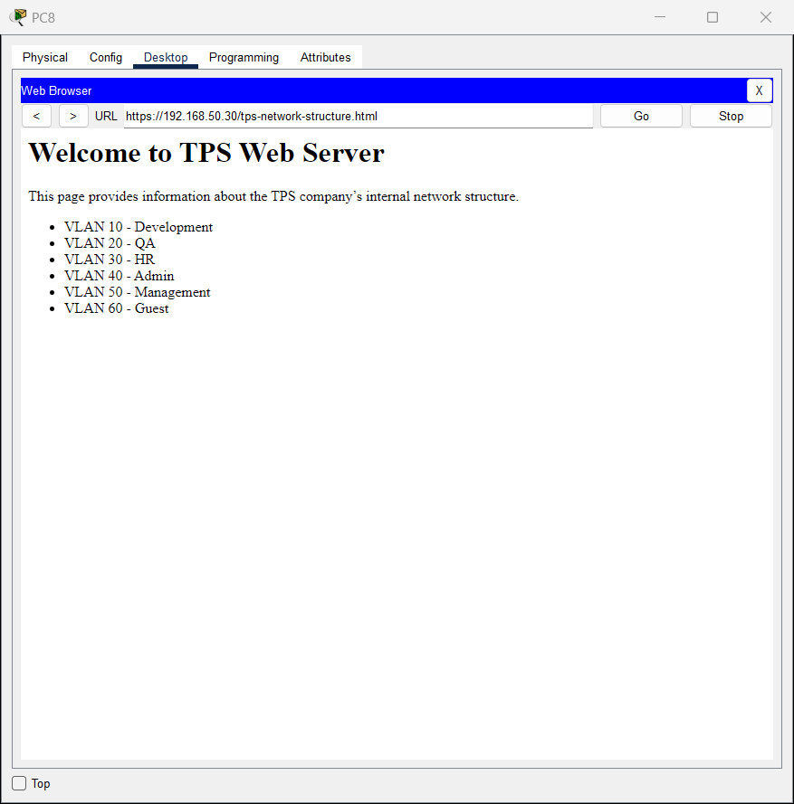

10.4 IP Addressing Table (DHCP Clients)
📷 Screenshot of IP address assignments on PCs in different VLANs

